Nowadays, indoor spaces have become essential for human activities, with people spending more than 80% of their time in indoor environments. However, multi-floor buildings, a common scenario in urban indoor spaces, face issues such as missing or attenuated GNSS signals. Therefore, achieving robust, low-cost navigation and positioning in complex indoor environments is one of the current research hotspots.

Our system utilizes Pedestrian Dead Reckoning (PDR) based on the Inertial Measurement Unit (IMU) to estimate the position of pedestrians in multi-floor buildings. By leveraging sensor data from smartphones, including accelerometer, gyroscope, and magnetometer readings, along with information from BLE beacons and WiFi signals, the system predicts accurate pedestrian trajectories and recognizes essential behaviors such as ascending stairs and using an elevator, which are critical for multi-floor navigation.

The system is designed to handle the complexities of indoor environments, particularly in multi-floor buildings, and is robust against challenges posed by the absence or degradation of GNSS signals. The system interface where the user can start or stop the logging of their position. This interface is connected to the underlying system, triggering the collection of sensor data and subsequent processing to provide navigation and positioning services. The structure of our system is shown in Fig. 1.

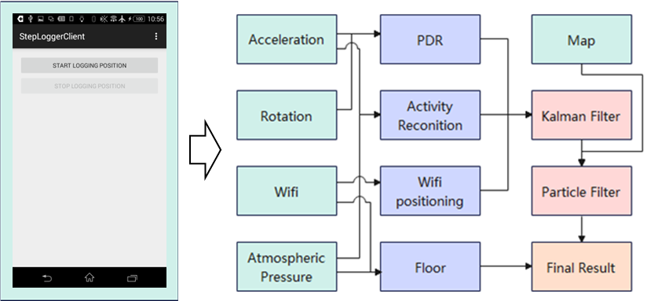

Fig. 1 System structure

**1.Activity Recognition**

Our system detects human activities based on attitude angle and acceleration using data from the Inertial Measurement Unit (IMU) in the phone. We first construct the training dataset required for neural network learning based on different human behavior labels. Additionally, to detect commuting behavior between floors in the scene, we added barometer data for training to distinguish between movement behavior on the same floor and commuting behavior between floors. As this work forms a component of a system under development to assist pedestrians in indoor positioning, activities common in indoor pedestrian tracking, such as sitting, standing, and walking, were considered in the development of the algorithm. In addition, our system can recognize specific human behaviors in multi-floor buildings, such as going upstairs and using a lift, based on the test set data processed by the trained neural network. This part converts IMU signal data into two-dimensional images, where each triaxial signal is adjacent to every other signal to capture the influence or relationship between the signals. These images are obtained using IMU signal samples, and the final labeled images used in CNN training are also processed using a 2D discrete Fourier transform.

**2.WiFi Fingerprinting**

In this part, the system uses WiFi fingerprinting for indoor localization. Features of the location are associated with patterns of detected signals (e.g., RSS vectors emanating from different WiFi APs). By scanning the AP signals of reference points in the environment with the smart terminal, you can obtain the signals sent by different APs and the corresponding MAC addresses of these APs. The received signal strength is indicated by RSS. Each location is represented by a unique RSS vector (RSSi1, RSSi2, ..., RSSin) based on signals from multiple APs. This one-to-one relationship between RSS vectors and locations is similar to the concept of human fingerprints, which can be used as unique identifiers for location information. Therefore, the RSS vector measured at a particular location can be used to predict its actual geographical location. In addition, we added the information of BLE beacons as a fix for map features.

**3.PDR**

PDR needs to complete three tasks of step count detection, step length estimation, and walking heading estimation, and its initial value is given by the existing data. Our system uses the accelerometer data in the mobile phone's inertial navigation to detect the number of steps, and the detection process is divided into the following three parts:

· a(k) is the acceleration value at time k. First, it is detected whether a(k) is a peak value, that is, the acceleration value at time k is larger than the acceleration values at the adjacent times k-1 and k+1;

·After successful detection, it must also satisfy a(k) > am, where am is an empirical threshold obtained through multiple experiments. Peaks below the threshold are judged as noise disturbances;

·Calculate whether the time difference between time k and the time of the last successful step detection satisfies a(k)-astep(i-1)>Tth, where astep(i-1) is the time of the successful detection of the i-1 step, and Tth is the empirical value of the time taken for a pedestrian to take a step.

If all the above conditions are met at the same time, time k is judged as the ith step of the pedestrian's walk. For step size estimation, we build a nonlinear model based on the empirical coefficient of the step size and the peak acceleration. For heading estimation, we first calibrate the initial heading with the existing information, and then use the strapdown inertial navigation algorithm to complete the heading estimation based on the IMU data, and at the same time use the geomagnetism to calibrate the heading.

**4.Kalman Filter**

The Kalman Filter (KF) is a recursive estimator that provides a mathematical method to estimate the state of a system in a way that minimizes the mean of the squared error. It is used to estimate the parameters of interest from a series of measurements observed over time which contains noise (random variations) and other inaccuracies.

In our system, we use the Kalman Filter to combine the outputs of the previous stages: Behavior recognition, WiFi fingerprinting, and Trajectory prediction, into a final, smoothed estimate of the pedestrian's trajectory.

The KF requires two main inputs: an initial state estimate and the error covariance. The initial state estimate is given. KF works in two main steps: prediction and update. In the prediction step, KF uses the system behavior model to predict the current state based on the previous state. It also estimates the current covariance. In the update step, KF takes the actual measurement, compares it with the predicted state from the first step to compute the residual. If the residual is too large, it means the predicted state is not accurate. The Kalman gain is used to update the predicted state and covariance. The Kalman gain is a measure of the estimated accuracy of the state. The higher the gain, the more emphasis is put on the measured state rather than the predicted state. After the prediction and update steps, the KF provides the final state estimate, which is a better estimate than the initial prediction. This process is repeated for each time step, with the new prediction and update based on the last estimated state and covariance.

**5. Particle Filter**

In addition to the Kalman Filter, our system employs a Particle Filter (PF) to further enhance the accuracy of the trajectory estimation. Particle Filters are particularly effective in non-linear and non-Gaussian environments, which are common in indoor settings. The PF works by generating a set of particles (possible states) that represent different hypotheses about the pedestrian's position. These particles are propagated based on the motion model and weighted according to the likelihood of the observed data. Over time, particles that are consistent with the observations are given higher weights, while those that are inconsistent are discarded. This process, known as resampling, ensures that the filter converges on the most probable trajectory. The combination of KF and PF allows the system to maintain high accuracy in both linear and non-linear scenarios.

**6.Floor estimation**

The system also includes a module for estimating the pedestrian's altitude, which is critical for multi-floor navigation. This module combines data from the barometer and WiFi signals to calculate the elevation change. The barometer provides pressure readings that can be converted to altitude changes, while the WiFi-based approach uses the signal strength from different access points on various floors to infer the current floor level. By integrating these two methods, the system can accurately estimate the pedestrian's vertical position, allowing for precise multi-floor navigation.